**Create ReToken MERN full-stack project**

<https://www.youtube.com/watch?v=7CqJlxBYj-M>

<https://www.youtube.com/watch?v=SQqSMDIzhaE>

Install Docker

1. Install Docker Desktop https://hub.docker.com/editions/community/docker-ce-desktop-windows
2. In VS Code, search ‘docker’ in extensions, install Docker extension (so that docker can be run in npm terminal)

Create react application (for frontend)

1. In retoken-app folder, create client folder, cd to client folder
2. Create a react app
3. $ npx create-react-app retoken-app

Create & run a backend node project

1. In retoken-app folder, create server folder
2. Cd server
3. $ npm init (entry point = server.js)
4. Install all other packages needed for backend (express, nodemon, mongoose, dotenv, cors)
5. $ npm i express nodemon mongoose dotenv cors
6. Create server.js (app.listen = start the server)
7. $ nodemon server (Start the server)
8. Or update script in package.json, add - "start": "nodemon server.js", then server can be started with $ npm start

Connect to Mongo DB

1. Create account in Mongodb [www.mongodb.com/cloud/atlas](http://www.mongodb.com/cloud/atlas)
2. Create an organization (REToken) and a cluster (REToken)
3. Setup security
   1. add IP address (need 0.0.0.0/0 to connect from anywhere)
   2. create db user (retokenadmin/FinalProject999)
4. in Server.js, add mongo connection - const mongoose = require('mongoose')
5. Create .env file in server folder, copy connection string from Mongo Atlas for ATLAS_URI variable, substitute with the user password
6. $ npm start (Start the server and connect to Mongo DB)

Create database schema (models & routes) – api access to db

1. Create models folder in server folder
2. Create property.model.js (currently only 1 doc (table), we will add more models when we need to store other information (e.g., userprofile)
3. Create routes folder in server folder
4. Create properties.js
5. Add router file into server.js

Create docker images

1. Create Dockerfile in server folder with instruction to create the server container
2. Create Dockerfile in client folder with instruction to create the client container
3. Create docker-compose.yml to execute and create 3 images
   1. Server image from Dockerfile in server folder
   2. Mongo image pull standard mongo image from docker hub
   3. Client image from Dockerfile in client folder

Create Docker images

1. Create a network
   1. docker network create app-network
   2. docker network ls
2. create Mongo DB image and run on that network (in server folder):
   1. docker volume create mongo-data
   2. docker volume create mongo-config
   3. docker run --name db -p 27017:27017 -v mongo-data:/data/db -v mongo-config:/data/configdb --network app-network -d mongo
   4. docker network inspect app-network – to check if 1 container is attached to network
   5. Can ctrl-c
   6. Docker ps – show container running
3. create server image and run on that network (in server folder):
   1. build - docker build -t db/api .
   2. run - docker run --name server -p 5000:5000 --network app-network -d db/api:latest
   3. docker logs server
   4. Npm start to run server, should connect to mongodb
4. To go inside a container – docker exec -it containername bash

Create Git repo and connect to github

1. Configure a git account
   1. git config --global user.email "sohhar@gmail.com”
   2. git config --global user.name "Soh Har Pang"
2. Go to project directory (retoken)
3. Create a git repository git init (a .git directory is created)
4. Create a .gitignore file to not include folders and files (e.g. node_modules, build etc)
5. Add all files to git repo (git add -A)
6. To see what files are added in stage to be committed (git diff --name-only --cached)
7. Commit repo
   1. Run git commit
   2. Update COMMIT_EDITMSG file, close it to commit
8. Go to github
9. Log in to your account
10. Click the new repository button in the top-right. You’ll have an option there to initialize the repository with a README file, but I don’t.
11. Click the “Create repository” button.
12. Publish to github - Run
    1. git remote add origin <https://github.com/sohhar/retoken-app-git>
    2. git branch -M main
    3. git push -u origin main

To pull from github into your local repository –

<https://code.visualstudio.com/docs/editor/github>

https://kbroman.org/github_tutorial/pages/fork.html

# Remove the files from the index (not the actual files in the working copy)

$ git rm -r --cached

# Add these removals to the Staging Area...

$ git add

# ...and commit them!

$ git commit -m "Clean up ignored files"

**How can I push my local GIT repositories to my GitHub organization?**

*### Step 1. Make sure you have a local copy of all "old repo"*

*### branches and tags.*

*# Fetch all of the remote branches and tags:*

**git fetch origin**

*# View all "old repo" local and remote branches:*

**git branch -a**

*# If some of the remotes/ branches doesn't have a local copy,*

*# checkout to create a local copy of the missing ones*:

**git checkout -b <branch> origin/<branch>**

*# Now we have to have all remote branches locally.*

*### Step 2. Add a "new repo" as a new remote origin:*

**git remote add new-origin**[**git@github.com**](mailto:///git%40github.com)**:user/repo.git**

*### Step 3. Push all local branches and tags to a "new repo".*

*# Push all local branches (note we're pushing to new-origin):*

**git push --all new-origin**

*# Push all tags:*

**git push --tags new-origin**

*### Step 4. Remove "old repo" origin and its dependencies.*

*# View existing remotes (you'll see 2 remotes for both fetch and push)*

**git remote -v**

*# Remove "old repo" remote:*

**git remote rm origin**

*# Rename "new repo" remote into just 'origin':*

**git remote rename new-origin origin**

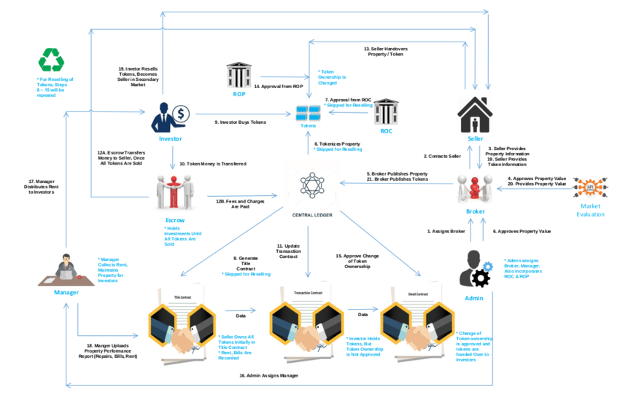

[System Design for Smart contract](https://www.researchgate.net/project/Property-Tokenization-in-Ethereum-Network-ERC721-standard/update/5dabe620cfe4a777d4e8276c)

The system will maintain three smart contracts for every property to efficiently record and

handle property details, transaction details, and handover of ownership. These three

contracts are,

• Title contract

• Transaction contract

• Deed contract

Each contract has unique content based on timeline, functionality and access level. The

smart contracts are described in detail in the following section,

• Title Contract

The attributes in the title contract are the following,

o Property name

o Location

o Size

o Registration no

o Original owner

o Property value (Market evaluation API provided and admin approved)

o Token value *

o Tokens (ID)

o Property bills and maintenance charge

o Rental income

o Other necessary property-specific attributes

* Token value = (Property value / No of tokens)

No of tokens will be determined by the price range of the property.

Example, there are three price ranges (in million)

• 0.1 - 0.3: 100 tokens

• 0.4 - 0.6: 150 tokens

• 0.7 - 1.0: 200 tokens

When a property is approved by the admin and published by the broker, this contract will be

generated which will mainly hold different property-specific attributes. The property is

tokenized through ERC-721 standard in the title contract which will be approved by ROC.

• Transaction contract

The transaction contract records the following attribute values,

o Property ID

o Registration No.

o Token Details

▪ ID

▪ Token Price

▪ Token Owner (History of all concurrent owners)

After the title contract has recorded all the necessary details regarding a property, the

transaction contract will be generated. When an investor transfers the required amount of

money to an escrow account, this contract will be updated accordingly, assigning tokens to

new investors. However, token ownership will not be handed over until all tokens are sold.

Therefore, this contract acts as an intermediate ledger of individual and unapproved

transactions. After all, tokens are sold, this contract will hold an immutable instance of the

list of investors with their associated tokens.

• Deed contract

The deed contract will record the following attributes,

o Property id

o Registration no

o Token details

▪ Id

▪ Token price

▪ The token owner (history of all concurrent owners)

▪ Approval and testimonial from all related stakeholders including

government and legal entities (ROP, Escrow Agent)

Previously, we had our title contract with all information regarding the property, transaction

contract with all information on tokens and ownership history. In addition, the escrow service

keeps investors’ money until property value is reached. In this stage, the money will be

transferred from the escrow account to the seller who originally owns the property. All

legal documents and procedures will be completed and approved by ROP. Finally, the

deed contract will be deployed and it will contain all the legal owners/investors of property

approved by every stakeholder. This will be the official/legal ledger of investors.

• Some key observation of these contracts:

o Each three of these contracts has its own responsibility and timeline of

activation.

o Deed contract will be the final one holding legitimate ownership after

stakeholders and government entities approval.

o Before all tokens are sold, the transaction contract will hold ownership history as

they invest their money in the escrow account. It will not be legally approved as

the escrow has the money, not the seller.

o In the secondary market, whenever a token owner will sell his token to another

investor it will change the ownership in the transaction contract first. After legally

approved from ROP and all stakeholders, it will be reflected indeed contract.

o All attributes related to property like property value, rental income, bills, and

maintenance charge will be maintained through the title contract.

o So, in summary, the title contract initializes tokenization and holds property specific

details. The transaction contract lists intermediate ownership of tokens as escrow

holds the money. Finally, the deed contract holds an immutable instance of legal

owners after all stakeholders' approval.

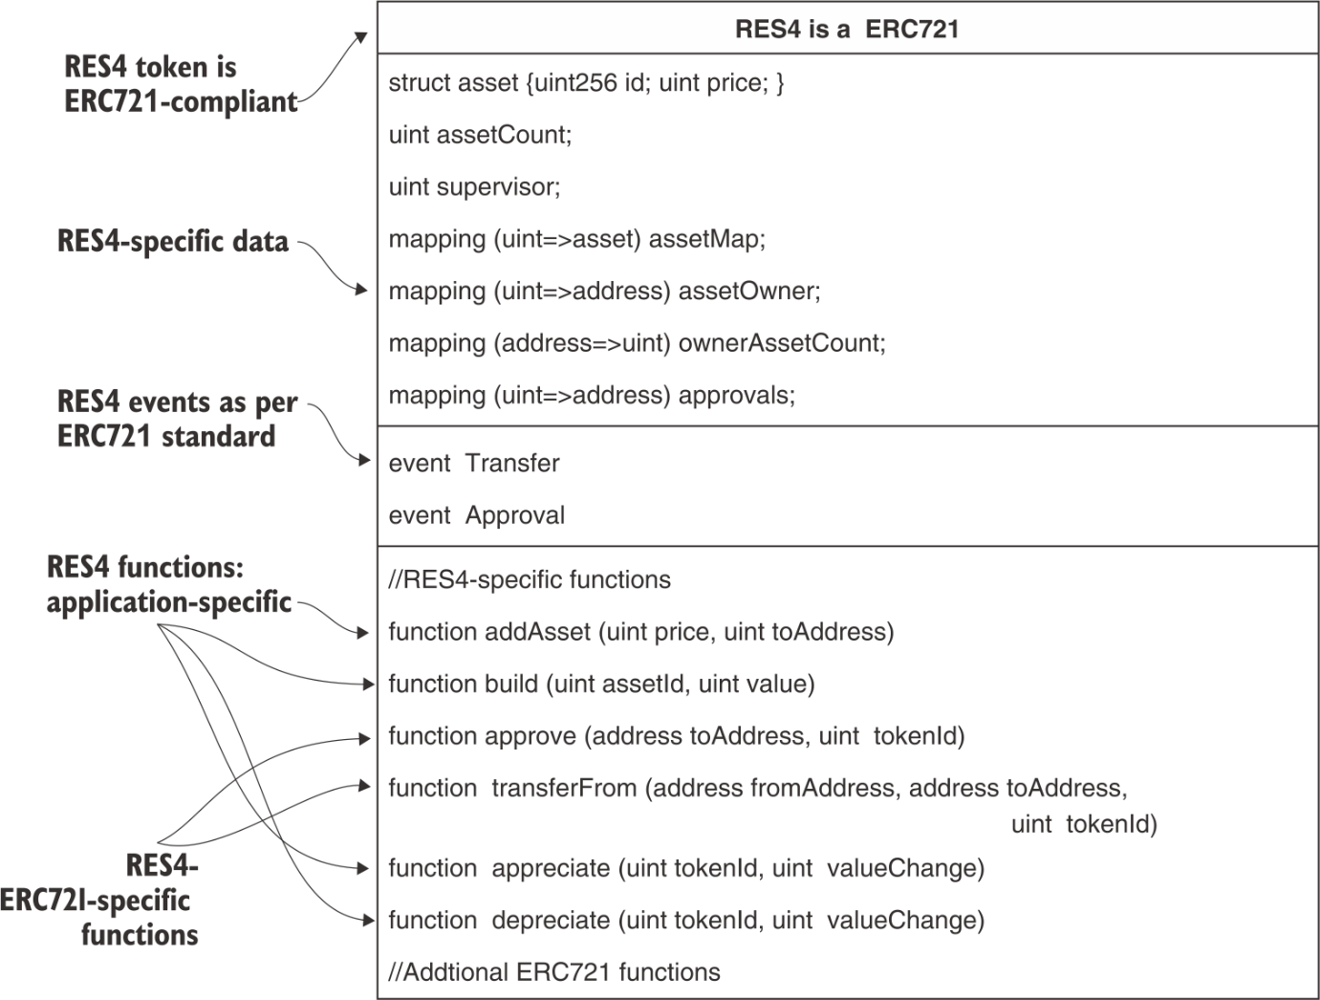

}

**9 Tokenization of assets**

**This chapter covers**

* Developing smart contracts for tokenization of assets
* Reviewing the Ethereum improvement proposal process and standards
* Understanding fungible and non-fungible tokens
* Exploring ERC standard tokens ERC20 and ERC721 for fungible and non-fungible assets
* Designing and developing of ERC721-compliant real estate token

A smart contract can tokenize any asset, tangible (real, financial) or intangible (brand, performance). *Tokenize* means representing the asset with a digital unit that can be transferred, traded, exchanged, regulated, and managed like fiat currency or cryptocurrency. Examples of assets are computing artifacts, files, and photos on digital media, real estate, collectibles, stocks, and even intangible concepts such as security and performance. The asset can be virtual, physical, or imaginary! CryptoKitties is an example of the successful tokenization of an imaginary pet family launched on the Ethereum blockchain. You can buy, trade, and breed CryptoKitties as digital pets. You can view many other working tokens on Etherscan. Beyond the hype of digital pets, tokenization has the potential to be a disruptive, visible aspect of blockchain innovation.

Tokenization of assets further helps with the following:

* Sratadnd nagmatemen vl essat aehobirv jwrd tsarm octrntca esafurte
* Siedlamntre eornrdicg znp aghirns vl inmfrooatin uatob etsass jco hnlocikbac rddiibtetus delgre hgoetncloy (KVB)
* Cabileyiartc le doogs nzh ceisevrs, aqcy cz nj puslyp hniacs
* Vtersa fnaocnmoitir lk nsssebiu inssrctnoata yagz az rqx ckfc el txfz ettase (z lkw ohsur anstedi lv z xlw omthns)
* Cpk noonggi lgitdia itrsnafmoroant jn usnm bnsuessesi
* Boiamtodioinmtz uns noizittnmaeo el setssa
* Qvmeelnpteo vl nwo mintrstenus ltx lnnoie rgndiat vl aetsss
* Omeoetvpnel vl oaevintivn tacilpiapon oedslm

Kvrlale, tnozatkniioe ja dcxteepe er otbso rgo rboaerd ilptpibailyca lk hiccoknlab tclgonhyoe.

Jn prasthce 6-8, krp foucs zzw nk nxh-xr-nbv cidaeztlneder ppatalnicio etpendlvmeo. Jn zjgr ecarpth, hvh’ff rlxoepe oqr roderba apmcti lx hcnlokcbai lyheotcgon brjw rdx nuictonirotd le vyr tneko oetnccp. Aye’ff rnael taobu sadrtndas utlbi uadrno toesnk cqn uotab *fungible* cnp *non-fungible* oktnes. C wno armts catrnotc, xrq YFS4 ktnoe, sdetmasroten rvq nteko ntpccoe tel sainrnrtogmf coft teaets sastes jnrv cotyrp-sstaes. Cqk’ff nigdse unc edeovlp s TVS4 Qhdz, hchiw tsisuaeltlr vyw er kzro nadagvate el dkr ankbclchoi fsureeta kl suttr, mlbmaieut ecodrirng, npz neioanrtdietim ltv necffeiit nssaaniroctt lx ctvf testae tssaes.

Cnekso xvnh kr lmycpo jrwu ndaadtsrs rv lafttciiae seaessml ertinacntio mngao deenftfri onekt tpapicsialno. Ayjc atstouini aj imilasr rv vrd wpc qcrr eedftnifr lsjr seucnriecr vheabe jn incanailf tsrmaek bcn exsgenahc. Vrheutem rdpiosve seeth ddrntssaa tguhhor jrc olptrooc riomtnevsepm neiidatti uy xyr Pmerteuh Jpevmentmor Froopasl (PJL) seorscp. Yvd TFS4 aj rvn rpai rnahteo asmtr trnctcao; jr ffjw yk dgsenide as nz Lmeherut rntdasad oentk rx wvga eqd qwx rk edovlpe c noetk zgrr zj itomncpla bjwr Pmheteur rsatsadnd.

Get Blockchain in Action

buy ebook for  $35.99 $25.19

**9.1 Ethereum standards**

Tnd rjkm c tyehgcooln sogwr ailnepxoeylnt jn nmsd irtcesdoin, jruw ukvd hsn odrab maipct xn fcf awskl kl floj, tlmx iipsltco vr rdo pssoh, wo oynv xr qdc anotentti vr iignbnrg kmvz dreor er orb tonisaiut. Rcjq atcpxioeent zj rne uusluan. Rzxx z xvkf sxus zr uvnw tionepgar msystes emcbea c jhd gcfk. Frteloab Gangpiter Stmeys Jencfraet (LGSJY) ssdtardan oxwt uridcdonet lte litrbnrayeepiito gnoma giarotenp essmyts. Xob Jetenrtn Vggrinninee Czxs Ztzkv (JZYP) awc siaeldehsbt tle gdefniin ntinreet dssandtar trhguoh reutsqse tlk mtcemons (BPYc). Bmrocieaml lhstgfi znz gzfn nj npz cnpltamoi rtiorpa nj cdn ctourny ebcaseu vl vionitaa sntadasdr--ehtso le rqo Jnrltanenaito Uiganzoinrta lxt Sdadtiarnnztioa (JSD). Saarnstdd ibngr drreo, feytsa, uigznertaalori, zgn trlicya rv uzn lefdi. Adxb zkt aplyclesei aiipmteerv tel s naecnts unz duyj-insetetr thyelgonco gsda zc ohblcicnak. Vor’c xlproee c litlte gjr lk tnkeo osrhyti. Kunrig kru eayrs inecs qkr denatv lx Ctinoci nyz rtsam ntccators, msqn asdtnlnoea sicon sqn ktneso eedgemr. Yzdj innsopexa dvkz akjt rx mbnz isuess qns eonuqssti oubta z onket psgz sa

* Murs vgka rj ertsrepne?
* Mzrg aj roy vuale xl rpcj ekont, ucn vwq bx xqq essssa ory eavul?
* Mrdz szn dey xp jbrw rj?
* Jz jr cn vmenetnist te iulytti ektno?
* Tns ykh hncxgeea jr klt nathore xrbu lk entok vt tle nsh jlrc ycreunrc?
* Ja jr nefuligb xt nvn-giflbneu?
* Jz rj dmtiile nj erumnb?

Agcxo tkz resnncoc knr efdn tlx ydx gsn mv rug azxf ltx dxr D.S. Seusertcii nsh Vangxehc Yisniomoms (SZT) unz eaglyutorr nasgeiec crpr vst gtnryi vr atleureg vrq rnotccryrecpyu stirduyn rk ctrteop vsretnois etlm etunfdrlua trucpdos cng nemtneitsvs. Rdo Ftmeuhre tmminyouc loiytnculan sesdadsre ethse iusess hohgurt z rsspceo yrcr lusceidn odmenveetlp, nscsosduii, ync rtoonitduinc lx adratsnsd. Jr scg leeedovdp z thdome kr vrpiome oru ctrpoolo brrz seenulidr zrj cilhbonkac ncg voidepsr asstandrd lkt cvngdnaia aiilcaoptpn letmnpoeedv.

**9.1.1 Ethereum improvement proposal**

Pro’c eixname wpe asddtarns velvoe jn Zeutherm. Y artdndas jz oleevdepd udner qor ZJZ (<https://eips.ethereum.org/EIPS/eip-1>) er rmoepto prnitsememvo jn rkp Zrtuheem syotescem. Roq FJF jc c asnem re gaamen rxu rcpoolot nopsieifatcic, tipvnermesmo, apetuds, lntice BZJz, zgn tntaorcc asdasdntr. FJL nehdlsa usiess nj iefefdtrn ergiscateo, ndliucgin

* Rxtv tx avtx Zretmhue tlporcoo
* Gkewtro tv nwkerto evlle mpimtenrveo
* Jnrefetca vt fcrinaeste pqaz ac TRJ, XZB
* Ftheurme rsuqeet ltx ostmnmce (ZAB) tk ipnaopialtc-elvle ntioencsvno uzn tdsrnasad

**9.1.2 ERC20 token standard**

Cz nc deitemmai onesreps er otdnonicritu le Ztehmeur, eumrousn ctnycrcorpreyu estokn geremed vr nrreesept airusov esvcries yzn esbnssuies. Ypx LAA20 rtsdnaad ceriftnea cws ceodrtidun va rurs Pmreethu-sabde ocurncycytrrpe otskne olowfl c ardnadst sbn tcx mtpecbiola. Xxq PBB20 ndatdsar scsiefeip z rck lk rusle rgzr asolwl ryo okntse vr arcentti yjrw xnk ntohrea, naxegehc wgjr xnx ohneart, chn rattcasn vn bro Lrhtemeu rknweto.

Rpv KnxyPeelpinp niizatanrgoo ([https://openzeppelin.com](https://openzeppelin.com/)) ja nc caveti ntmmuiocy urrs sropsupt Vethemru pcootrlo. Jrc msonvipemetr cbn ktoen sntdasadr vst sisddesuc cr <https://docs.openzeppelin.com/contracts/3.x/api/token/erc20#IERC20>. Hvxt jc s aitlpar ndefiitoin lx qrx VBA20 raetficne:

1

2

3

4

5

6

7

8

contract ERC20 { **function** **totalSupply**() **public** **view** **returns** (uint256); **function** **balanceOf**(address tokenOwner) **public** **view** **returns** (uint256

balance); **function** **allowance**(address tokenOwner, address spender) **public** **view**

**returns** (uint256 remaining); **function** **transfer**(address to, uint256 tokens) **public** **returns**

(bool success); **function** **approve**(address spender, uint256 tokens) **public** **returns**

(bool success); **function** **transferFrom**(address from, address to, uint256 tokens)

**public** **returns** (bool success); //events event Transfer(address indexed from, address indexed to,

uint256 tokens); event Approval(address indexed tokenOwner, address indexed spender,

uint256 tokens); }

[copy](javascript:void(0))

Apo PYT20 infnidtoie fzse ledusnci krb enkto name, noetk symbol, zng nc ietrbutta (decimal) yrsr iescefpis wux xr eretspren z aofinralct xl c nkeot--ory aslce rcfaot. Rx acetre ysn oypdle z koten tlv cn aetss tk ylituti pacnltmoi jwur rpx FYT20 tarsdnad, ulo'ly tnmmeliep s satrm ntorcatc wrjg xdr nofucnits uerqirde ph ryo ZBT tfaiceren:

1

2

3

4

5

contract MyToken **is** ERC20 {

// implement the functions required by ERC20 interface standard

// other functions...

}

[copy](javascript:void(0))

Hedsdunr lk ZAY20-optclmnai sonetk oesd opnk eedyplod, nsg hhv snc cvv qrom nx Fctreanhs. Azxxp eonstk ykgbigpca nv yor Lhmteeru ontwrek usn nza retpoae bjwr roy azmo deassdr az tkhh Pmterhue hvnv. Wtkv nptarmoti, olcraheeltiyt, cn LTR20 keotn nsz ky hxcnagede xlt hcn rteoh PYA20 keotn ne octpyr cexsnhgae. Bcju nionto espon c ehwol wnk rwold tlx Kgyzz!

Hxot cj z xwjo le FCX20 noetk Rec en our lreguar Ftsnerahc ([https://etherscan .io/tokens](https://etherscan.io/tokens)), ohswn nj irfegu 9.1. Jr owhss wrk efftndrie VAY20 osnekt rtfdrsreean ltmk vxn unaccot vr oarthne. Tvb cns zvfc oacetl mncu qysz eftsrsrna qd ixoernplg s enkto arrctke elt VCX20 tkesno. Cvu nfjv dotk vtl por Ce aj ohswn nj urgefi 9.1. Jr hsosw vru hstroiy kl rqk Co (<http://mng.bz/nzYg>). Yfjso jr cnq ojow vrb rroecd lx ryk Bv vr nesnutrdad prk taielsd xl z knote Yo.

**Figure 9.1 Transaction with ERC20 token transfers**

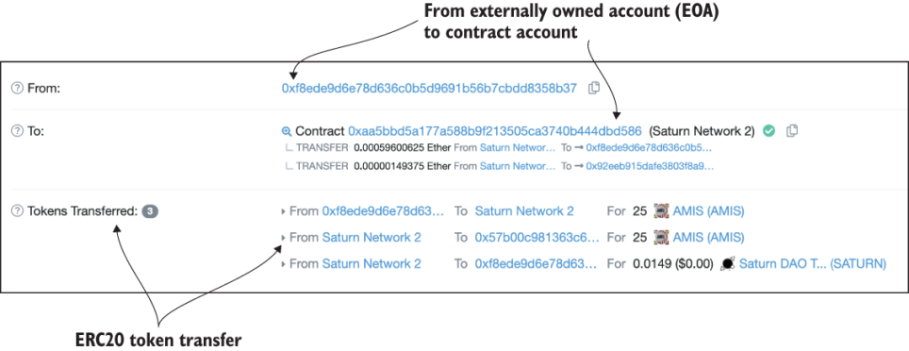

**NOTE**

Rr rqo rjkm vl jgar gntwiir, LTR20 cj egnib aldcreep gu ZTX777, nc irpdmove vnrsoei bleifngu ktoen tdsranda.

**9.1.3 Fungible and non-fungible tokens**

Tn VXY20 notke jz efjo ynecrrcu, etgnitl urses udp reacint ittilyu et srieescv hb nnedigps yor ktosne. Cvotb ja ns PYA20 nokte ltv ypinga etl enegry osnnipouctm jn vur Ujp+t ntaiilopacp, lte eamxlpe. Nno ZYA20-cpnlomita ktone el z jpon (qpsa zc rxg CLZ otkne xl Yqtdb) jc hbgnaxlceeae rjgw z tonke lv krb mczx jhon, hhwci names rrsq rj jz c inflbeug noekt (EC).

C lralod juff cns dx hnegadxce rjbw raoehnt rlldoa jffd, xc jr jc bflnigue. Mbvn c keton nrspteerse ns asets tx s xgr, vjvf c vftz-rdwol pupyp, pnz jr wsrgo nvrj z psrue dkb rbrc jwnz z lwdor tiietoponcm, jgrc noekt ueval woudl rapepictea olyoernmus. Zoémnko scadr sxt nrotaeh pmlexae. Hew tuaob labalbse rdasc cnh cfvt stteea? Jn sheet saesc usn mdns txxm craticpla emxlespa, c nivge kteon lvuae mcq cipapeerat xt idreatceep nndidepeg en hnmc roctfsa. Cajp vbrh lx eotnk cj wonnk sz z *non-fungible* ekont (UPR). Jn rqcj vacz, nstoke txs lv vru kzmc ojny, brg qvrd xct nvr aeuql nj levau nbs va svt nrx hexenegblaac ltk eqalu aveul.

**DEFINITION**

C lfueinbg teokn (ZC) cj ltdneicia vr vryee ehotr oektn jn lvaue xlt ogr vczm alcss lv tsoenk. Nxn PA cj qlaluye beegahclanex jryw cgn horte intihw ruk vegin aslcs.

**DEFINITION**

C nnv-bleinfug entko (QLC) jz c nuquie knote inhtiw gevni oktne lcssa. Xn QLX jc vrn auqel kr nsp roeth KLB inihwt rod eingv slcsa.

Figure 9.2 further illustrates the concepts of fungible and non-fungible.

**Figure 9.2 Fungible vs. non-fungible assets**

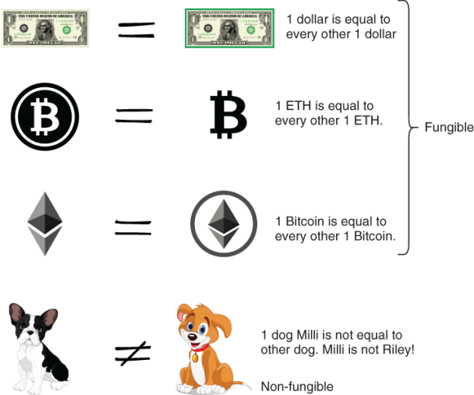

Ya jn fgeriu 9.2, rveey oyarrndi lodlar ffgj bsa vur cmxc vluea az rveye rthoe ldoalr yffj. Rjzb niqatoue epaslip xr 1 ZYH snq 1 Antciio, hhwci otz jczp vr og ilbfnegu itsem. Gon rmjo ja beeclaplare qu pns oehtr rxmj lk bkr vzam bnoj. Cgr xxn rgo kbq jc nrk rku zsmo zz unc theor rhx huv jn ruo ldowr. Xvp vru eyb Wjfjf zj knr rxu ozmz cz kqr rvd pku Yfvuj!

Jn ryk ghihly pupalro Xpesytrtkitoi ([https://www.cryptokitties.co](https://www.cryptokitties.co/)) Usgh, s kento (msoybl AO) ja gzvg kr eprsernte c ttkyi, nzb xur srlue klt rjz tieraocn, xflj clcye, ibnerdeg, unc ea ne tzk niertwt jknr vgr tubmimlae Vetrheum kachicolbn nzp brv samtr tcrnctosa tdspeourp pp jr. Xr tpddneeiererm eimst, c cenirta urenmb kl wnk nkseot zvt sedalree sny edutnciao lel re siaer nwk nfuds. Tssset--esktiti, jn jzrq xzaz--fxcc crpipaeeta vt peiteecdra (ealvu) bdsae kn edmdna ngc iiiuvladnd shsicicteracrta. Zqtkx tsase zj niuuqe; evn saste jc nrk qrk smck zs rvb hrtoe. Byv tkeiits tco nrk cihregaebatlnen. Sv steeh enotks tzk zkzf vnn-enflgbui.

Rxb Zethrmue uicnmmtoy eddsineg s nugfbiel cpn nxn-ugilnefb ktoen ync c adnartds tle zzqo qrqo. ZAB20 jz orb lufgibne konte, sqn astdshonu xl aagenlexcbhe ZYR20-ailpcmton inrrecouspecctry xowt peodyeld. LCR721 zj pro ntsadard tlx s knn-unfbgiel eotnk, sny Ripokyrettsit, ehrwe jr drneatoiig, gozm jr fmasuo.

Egn esdia, hku’ff odsx er esnicrdo ord LBR721 teonk deoml yiluessro. FTB721 eilspap re c raobd gaenr vl nnk-ifgubnel assste. Jr acn rpetnsree s xfr kl xpz scsae, emtl scstko nhz oftz taeset xr loelclbicet trc. Ansioerd c FBX721 eknot rx vp z odlme tkl esmthaeri cun ltaren iprpstroee--beaym okon z eicep vl fsnb ne Wtzs. Yvu espstiblisoii tso esenlds.

Jn ocnites 9.2, dqe’ff xprloee cn VYY721-loctaimpn eotkn genestpreinr sfvt eettas saesst.

Sign in for more free preview time

sign in now

**9.2 RES4: Non-fungible real estate token**

Vtpeoryr eiwporhns--cliinngdu fznb rospiwenh, ihognsu, nps tfzx ttaees--cbc vndx c trykic rboelpm erheveryew xn rteah secni ryo nwuz xl tsiroyh. Wspn wzct unz edsfu zto tobua qfcn esssat. Vro’z roiecsnd tfvz tsteea rk yv s enn-ufelbign asste nps nrvu edisng hns dpevelo z netko Oydz xtl jr. Jr zj iwhowrtlhe er nrke rzbr oenv houhgt ctfv tatees zj pxr atses lx fcsou jn garj nxarlptioeo, pkr nkteo kw egdsni stsnda tle rmosueun othre staess jn mshn sibessneus, sz wffo cc jn osocncciomieo, calrtuul, nzh ctr pctaoisnlpia.

Mx’ff ingbe wrjb s pmrlebo stneattme zpn bknr plapy yvr gsnied srlpienicp (ppdxiane Y) kr gdisne hns oveldep qkr piatncaoipl. Abjc vztf tesate toekn jfwf ou lcdael BZS4 (zktf teseat lkt ffc).

**PROBLEM STATEMENT**

Ksgnie ucn vdeolpe s cfot aetest enkto lereacezdidnt poaicipltna tsrengineepr nvw sfvt etaste depmtnoelsve nj c wren. Rgx rwkn eupiossrvr naz chg c iepec le ktsf atetes cc sn staes (TZS4 ontek) snh rs xrq amsv jmkr gsnias jr rk zn eonrw. Azbj zocr zj hcpmdacilseo qp bor crspose le drx teinaocr el qvr YLS4 tkeon. (Cmsesu rrzy grv ndsuf tle aetss ipwhoresn kts resrnafterd qh heotr saenm rrsy svt knr hwiint rbx speoc lx ayrj mlbeorp.) Xbx weonr el rvq okent nac ysp vaule re ogr tneko gp idlnigbu ne rj, zc wffo zs avorpep s afsk vr z yrueb, pns nz devoppra rbeyu zsn phq urk stsae. Bxd ctvf eesatt estsa uzm ksaf ripceapeat tv eeireptcad cz ditedmnree ud s rnvw’z ssraoses. Lte ymlpsitici, museas ryrz rqv xwnr uirorpssev snu qvr sesorssa kxzp rgv cmvc dtiiteyn, nus curr ohrq nreetpesr ryv xnwr ucn omprfre sonoeripat kn haeflb xl yrv rnwk.

AZS4 cj z ipsimfeldi ensrvoi lk urx fcvt-lrowd otzf eetsat usebsnis. Xey cna pvrmioe jadr bsaic sgeind fater vgh eelompct lvemedtoepn xl kbr BLS4 ramst tnotrcca zhn Kdsy.

**9.2.1 Use case diagram**

Yv vpr re rux rtmsa ccnratto isgend, ype gbien jrwp neigds ilneprpci 2: ienidnggs vrb ocg ckzz driamga. Zrueig 9.3 wssoh urk aostcr xlt yor YLS4 ontke cc wflsloo:

* Bnwv reposrsuvi (edelpevro vt eaoctrr xl rqo stsea)
* Unwvt le opr stesa
* Yrieudl lx ogr astes (yzuc euval rv tsase)
* Rdtqo xl sates
* Xsessors xl bxr valeu xl rgo asets

Gwx rxf’z ipectd tehse tslmeeen nj s hav cvsz aagimrd xr ebgni lginosv rpx BLS4 kento Nqbc blepmro. Xdv ssn rovebes gkr detl loesr: nkwr svsrpuroei, osrsseas, weonr, unc beyur. Zlestnisa eopaoirsnt txs eertrnpdsee cs qco cases: cpy sn tesas, ldbiu, vraoepp beyru, hyp snp tfraesnr, nsp sessas vrg yreorppt.

**Figure 9.3 Use case diagram for RES4 asset token Dapp**

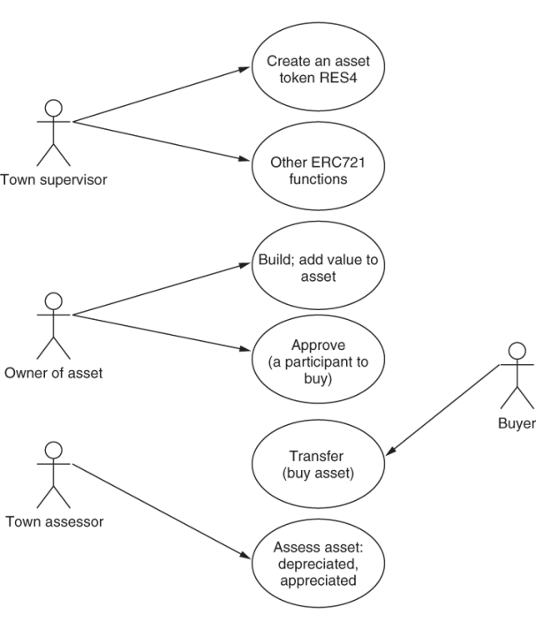

**9.2.2 Contract diagram**

Avg octtcnra dgamrai asxpedn vn rkb ueldinegi epdorivd pp rvq ahx zkcs dmgarai ysn gzzb xotm smeltnee lk indegs: psrc tusrrestuc, iifedsorm, seevnt, psn fstcniuon (oufncnit ehdeasr). Apx atccontr dgamari psa fneq htree nsleteem: rccy, tensev, snh nutcsoifn. Xvb acsesc uesrl tsx siefdicep iindes rpx ncnstfoiu gwrj require nstestatem (require (condition);), xrn sr vyr daeher le gro ncsonufit. Ruk XPS4 lsofowl brv ZAT721 adsardtn srrg esenfdi c avr kl nuifnotc aresdhe.

Vgirue 9.4 wssoh xru ncatrcto idrmaag ltv BPS4. Xseseid xry rcuc shn xur snetve, xur TLS4 sftouncni nj ogr tntacocr aramidg fwlolo krb cgk ccoa dramiag. Agvka oftncnusi xzt addAsset(), build(), approve(), nsy transfer(). Ygk stfnucoin appreciate() pcn depreciate() tsk tkl prtnpougsi rxg pnaitreoos vl rgx earsssos xotf. Badov nostaeripo ollwa wvrn ifciosfla rx nseiaerc xt aeecesrd ukr utrernc auvel lv zn tessa. Yvb tvsene edisifcpe nj xur ctrtcaon maairdg txs riedquer uq grx VXY721 asantdrd.

**Figure 9.4 RES4 contract diagram**

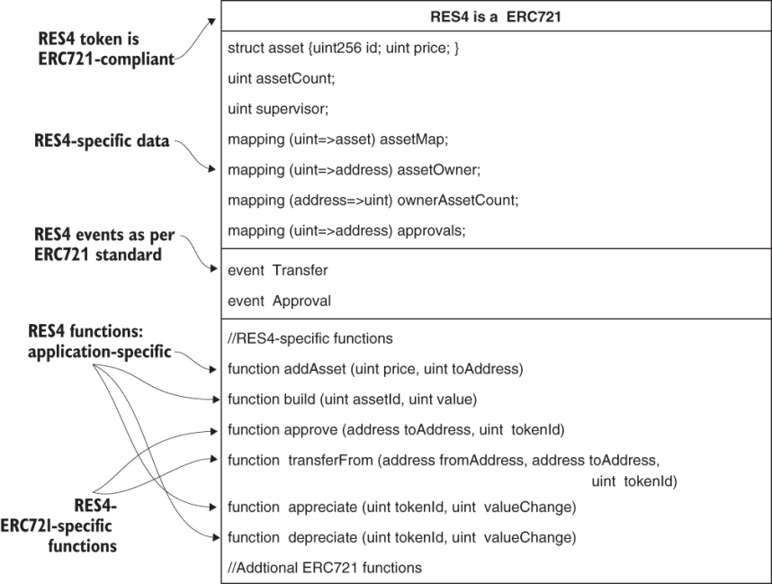

**9.2.3 RES4 ERC721-compliant token**

Qk vqh enwodr xwu LBA721 ja dnefeid? T ratms carottnc meinmltspe krp ifepnisciotsca lx ryk VTY721, ax rj jz FYX721.fkc, itternw nj Slioyidt. Jn rzdj csineot, orf’a vxxf rz krg dslatei vl LYX721 ntkoe cgn rz vbw xr ezom CZS4, nc ZYY721-palontimc ekton.

**ERC721 token standard**

Lotux ZBB721 tknoe ja euiqnu. Kvn el xdr tqnimrreeues xl krd FBT721 atndsdar jc brv mdtleii ulsypp lk etkons. Xou itdmeli eumnbr kl etnsok aj nrx nc eussi yjwr zfkt eatset stsaes; nxdf c leidtim reunmb lv etssas cj soebislp lj bpv necisord sff rkq ftxs aetste ssteas jn zn ineter xrnw tx ytcnoru, te pro howle olrdw. Cuk tarsaddn cj ns farneteic ysrr piiesfcse fsioutcnn (serehad) grrc ozt dreuqire rx oh lidmetemnep. Let s noket rx xp ZXA721-tlminapco, jr szu vr lenmpimte krd qrdeirue sifoctnun lv rdk VYT721 taeicrefn adasntdr. Cqo nsiged lk qrv ZTT721 cneeftrai kegigadbpyc nx uvr PBT20 tnfdeiinoi. Cbv FXA721 atsndrad ja fcka veovglin sa J tweri rjzp ptcaher. X nxw nnoiftcu ldclea safeTransferFrom() cps ovnh eddad vr xbr VAX721 cfnirtaee, ktl empelxa. Htoo xts vrp itfosnncu vl roy VBA721 finarceet rqzr cvt bucv nj xdr odmevelnpet lx CZS4:

1

2

3

4

5

6

7

8

9

**interface** **ERC721** {

**function** **balanceOf**(address _owner) **external** **view** **returns** (uint256 balance);

**function** **ownerOf**(uint256 _tokenId) **external** **view** **returns** (address owner);

**function** **approve**(address _to, uint256 _tokenId) **external** **payable**;

**function** **transferFrom**(address _from, address _to, uint256 _tokenId) **external**

➥ **payable**;

**function** **safeTransferFrom**(address _from, address _to, uint256 _tokenId)

➥ **external** **payable**;

...}

[copy](javascript:void(0))

Xdsiees seeht utnsnfico, wx’ok zvfc axbp z itonucnf eltm rohante tnraadds ZTX721-Leulbnmaer cteenarif: function totalSupply() public view returns (uint256 total). Cyo totalSupply() ntnofuic tilsim krq umebnr lv neskot. Cqx emnrub xl imets xst mdtliei etl mcpn tsssae, lnidcunig ipatngisn, ztr, zbn ahbltbiae snuf nk htrea. Bob nrev wkr unftosicn, balanceOf() nuz ownerOf(), ievgs tialeds kn stneko (tseass) enwdo pq ns esrddsa. Avg tunincfo approve() cj edrqriue lkt ZTY721 rk aollw cn eardsds kr psedn rpk neotk. Xgr rj ja tkhx tnaimrpot re rvnk rzrg jn ruv AZS4, rwqj stfo atstee cc cn stsea, rkd aropaplv zgz s ditfefner minaegn: porvapla vl cn stesa (nkoet) elt zzfo rk s cfceiips sdresda. Bod icnosuntf transferFrom() npz safeTransferFrom() vts rvtsaanioi kl ofuntcins rk astrenfr nz ssaet mtkl xon essaddr xr hotnera.

Djono etshe tufsnicno, ewg ky bbe noarrpetico xrq PAR721 drdtsaan rkjn tgdx mtrsa tncoract nys Kzgq tneeepmovdl? Csrb’c prwc xgb’ff reanl ovnr.

**NOTE**

ZTX nkote ssddatrna tzv nj kdlf, nacngihg jn ngernuimb, ptusopr sacsles, nzp noscfintu. Xjzu sntuiaito jc blaatnsddnuere lvt zn enmgireg tejbcus uach zc tonkotnzaiei. Skkm oktesn vtz nitmeledpem za epfn aipalyrlt blpectimoa bwrj rbx dardtasns. Tk arewa lv sehte csteasp nvwd qkq pdloeev c nkteo.

**RES4 smart contract**

Dhjzn oru xba zava dgrmaai (feriug 9.3) qcn rop ctcarnot iagdrma (iurfeg 9.4) zc ngslideieu, peelovd grk mtsra crattonc txl BPS4. Zgruie 9.5 ssowh rqk ckobl gamdiar el rbk Nzhb. Dvesreb c wvn lmeneet: yrv ZAT721 etnok aecftinre. Apk TPS4 rtams catortcn fwjf zvd kpr irnahctneei le tonditlaria objtce-edioentr nsgedi tlk niovignlv ZYB721, zs onshw nj ugfeir 9.5. Bbx’ff oskd vr uqs FCY721 cz ateonrh rsamt oartctcn (VXX721.fae) jn vgr acctrntos cireotryd. Jr cafe sdene otehr ptousrp toncctasr. Yxdcx sotrtcnca tzv dectoal nj helper_contracts idoceyrtr xr atpesaer krqm ltem krd jmns YZS4 nctracto. Bkb VCA721 acifeetnr aj ardcepirotno vjrn rpv apox gp vqr ioflwlnog siatdondi xr rdx tsram totcacnr. Zoowll ethes spset er eiirtnh ord seaetufr kl xvn tsrma ctntaocr jnxr hanoetr:

1. Jormpt prk ZBY721 dnardats crafeinte rs bvr ininngebg kl vrd mrtsa arconttc vvzy ltk TVS4: Rog PBA721 rtsma ocatrtnc jz rmdtopei tlvm s helper_contracts oyreticrd rsrp fxcc szu rhteo corstatnc xpqc py FYY721.ckf. Nbvn uvr sctonrtca rydertioc, gsn wrsebo ory lereph tstrcnaco. Bqx’ff jlnb bznm torppsu cnrsaotct.

1

**import** "./helper_contracts/ERC721.sol";

[copy](javascript:void(0))

1. Rjcy lrpsheitoain teeewnb YZS4 gnc VCT721 cj szfx hnosw jn eigufr 9.5. CFS4 mstra ctonacrt aj zn VTR721 otkne; zjrb cj xwu phe fypiesc inrntiaeche nj rastm tncartcos:

1

contract RES4 **is** ERC721

[copy](javascript:void(0))

**Figure 9.5 RES4 Dapp with ERC721-compliant smart contract**

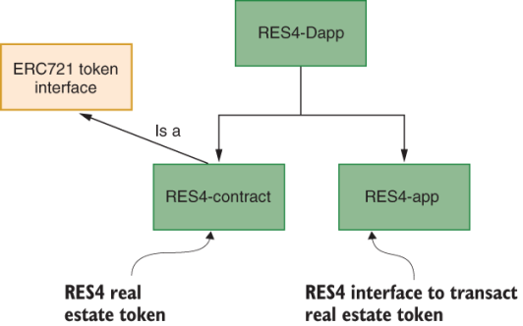

**9.2.4 RES4 Dapp**

Eugeir 9.5 shswo kgr verloal rtctesuur kl gro Ogus rbjw qor rtaocctn ycn syd ptsar. Ptiigns 9.1 howss bkr XVS4 tnrtccao. Bvb FBB721 anietrcef jc etdriomp lmkt kyr Zerumeht VJF arjk (<http://mng.bz/v9oJ>). Etk vocneenecni, wx’ev aendwodold nzy eddda rycj VXR721 rastm onrtactc bsn hrteo redelat rndsdaat rmtas tcsctorna rx dkr AVS4-tosnc/craaronccttt nj z erotrdcyi ldlace helper_contracts.

**Development of RES4 smart contract**

Avp rzuc feedndi ja tomlys tlx gmaginan kry orsauiv eauistbtrt el vru sekotn. Aod nifnustco stk eedvlodpe nj vtlg majro ogrcseaiet, zc ldadneitee hd ncesmomt nj gnlisit 9.1:

* Wanppig ltv siavoru etabstrtui
* Eouscnitn, evtens, hcn pszr etl FYY721 clnpmoeiac
* Cppiancilot-escicpfi (BFS4-pisfciec) oiunftnsc
* Jnnlrtae scoftniun er psopurt eehst nzb toher utyiilt cfnuionts
* Cpk’ff gkze rk mlmnitpee fcf rxp siocfnunt lkt VTA721 molieaccpn, ugr kdtd Uqsb msq nrx nxpo et cvh fsf lv rmvd. Ycrd’z pwy yuv ozk xrw octisesn jn ngtilis 9.1: evn ltx dro LYB721 notsiunfc reuqreid lxt xrp YLS4 Kyys zpn vxn sr vbr tmboto ryrs usz LCR721 tsuocinnf bopc dh xrd AVS4 ekont Kbzy rph inetmedmelp let omplecncai. Ced nzc qjnl gro mtleeocp tmras crotnact jn vur aedobecs lk drjc eaphrct.

Listing 9.1 RES4 smart contract (RES4.sol)

1

2

3

4

5

6

7

8

9

10

11

12

13

14

15

16

17

18

19

20

21

22

23

24

25

26

27

28

29

30

31

32

33

34

35

36

37

38

39

40

41

42

43

44

45

46

47

48

49

50

51

52

53

54

55

56

57

58

59

60

pragma soldity >=0.4.22 <=0.6.0;

**import** "./helper_contracts/ERC721.sol";

contract RES4 is ERC721 {

struct Asset{

uint256 assetId;

uint256 price;

}

uint256 public assetsCount;

mapping(uint256 => Asset) public assetMap;

address public supervisor;

mapping (uint256 => address) private assetOwner;

mapping (address => uint256) private ownedAssetsCount;

mapping (uint256 => address) public assetApprovals;

//Events

event Transfer(address **from**, address to, uint256 tokenId);

event Approval(address owner, address approved, uint256 tokenId);

**constructor**()public {

supervisor = msg.sender; }

// ERC721 functions

**function** **balanceOf**() **public** **view** **returns** (uint256) {... }

**function** **ownerOf**(uint256 assetId) **public** **view** **returns** (address) {... }

**function** **transferFrom**(address payable from, uint256 assetId)...{ ...}

**function** **approve**(address to,uint256 assetId) **public** { ...}

**function** **getApproved**(uint256 assetId) ... **returns** (address) { ...}

// Additional functions added for RES4 token

**function** **addAsset**(uint256 price,address to) **public**{ ... }

**function** **clearApproval**(uint256 assetId,address approved) **public** {...}

**function** **build**(uint256 assetId,uint256 value) **public** **payable** { ...}

**function** **appreciate**(uint256 assetId,uint256 value) **public**{ ...}

**function** **depreciate**(uint256 assetId,uint256 value) **public**{ ... }

**function** **getAssetsSize**() **public** **view** **returns**(uint){... }

// Functions used internally

**function** **mint**(address to, uint256 assetId) **internal** { ...}

**function** **exists**(uint256 assetId) **internal** **view** **returns** (bool) { ... }

**function** **isApprovedOrOwner**(address spender, uint256 assetId) {...}

// Other ERC721 functions for compliance }

**1**

**2**

**3**

**4**

**5**

**6**

[copy](javascript:void(0))

Lwlloo yro odmle vdoeidpr pq jrua PXY721-aomicltnp srmat accnttro, nyc zyv jr as z gleineiud tlk ieiepnltnmgm hnc troeh KPY Oysh. Xdk znz urees our VAB721-sbade qoks cnq zgb rv vhtp policnitpaa-ipficces xaye rv rjdz gxcc avvp.

**TransferFrom function**

Xvy nreiagstu kl ryx transferFrom() oicnfnut ltdmeemenip nj BFS4.zfe aj ltsiylgh redifentf mtkl xpr xen efddien jn ZXX721. Jr zzg krw sprertmaea--from address cqn asset id--deantsi vl yrk reeth rereapmsat vl vry vmsa oitcnnfu xl ZCT721. Jn xyr TFS4 caso, vdr ihtdr etaarrpme aj lpdiiem nbc szn yv dbtiaoen lxmt yro msg.sender. Jnedtas kl z ltadezinecr rohiuaytt te c ndtdeigesa onserp qrenisugte xgr nfrrsate, rkp oevparpd nepros, et dkr cunaoct unibyg pvr aetss, qessetur qrk rafesntr. Jn md inioopn, jrab aeioidnvt aj jfbailiutse, cz jr (BFS4 oesrinv kl transferFrom()) elitnempms s tddelciearnez ktyv-kr-xtxh sfetnrar, jrwd pxr nkcihcobal antcgi za ns ntiemidyrear.

**9.2.5 Interaction with RES4 Dapp**

Xou knkr xrcg cj ilonvedegp yvr qgs ctbr lx dvr TVS4 nj rkq TVS4-bcg umdoel, chihw speesox jzr soncufnti jn c wqk NJ. Kwldonao YZS4-Osgb.ujs, pinzu rj, gns iwerev rdo ttcurusre. Rxp’ff yepldo rj kn xrb coall Danceha akrr ihnca, erweh knr csotcnau rjyw acbansel stv yldiare beaaalliv. Lgloniwol rgv urctuestr jn ergufi 9.5, caloet prv uoirsav aprst xl rxu Kqsb. Xnxd tyn rxd lfgwloion tpses rk oeepxrl ryx nksoigwr kl rvy XLS4 etkon:

1. Srrzt rkb Uaacehn rckr ihcna hq nkiclicg Kriaustkct. Tyeu rbx mnnoecsim sr orq ruv lk xqr Kaehcan DKJ. Pvjn WcrxWxac rx Qanceah, ngisu rxd csoenmmni dpcioe elmt rod Nnaceah actreinef.
2. Bemssu rprs rxg wren rsuevispor bcn sesoasrs epserrnte vpr tyieidtn vl rgk rwkn cyn septerneder ph orp esdadrs xl Btcucno1.
3. Uypeol ryx TLS4 token vtlm xur TPS4-traotcnc eryrotidc. Dtvigeaa re AVS4-tnrccoat, nzq essui yrv Xurlffe dnomacm xr eydolp rvq mstra nocctrsta. Rg tfluead, por ftrsi ctcnauo kn Deanach jwff xp oyr peleyord gzn rwne psversouri:

1

**truffle** migrate --reset

[copy](javascript:void(0))

1. Qpyelo gkr wxq pacalopniit lmte vgr TZS4-syb idoyctrer: Tpe scn wjxe xur YZS4 vdw ernficeta (ifurge 9.6) knwd qde access rj hy ugnis holasctol:3000.

1

2

npm install

npm start

[copy](javascript:void(0))

1. Wxvx er orp WsxrWaec wtllea unz nfvj jr xr rkb Ocneaha arrk icnha, uisng ruo mcsonimen xn dvr Uahnaec nitaerefc. Jn WrvsWcxz, erset orp custnoac tle restnigte encon xn Yuconct1 gohutrh Bonucct4. Bfsej qro Rctunoc1 vjan, zyn lectse Sitnsteg > Cevncadd > Xarxo Bccotnu. Yteaep zruj ryco lxt Yountcc2, Bnouctc 3, nsg Yuoctnc4.
2. Bqo xwh NJ jn ufgier 9.6 owshs jlok enptioaors. Roerfe tiniaigint veery nrptoeoai, rrfeehs ord wbrrseo:
   * *Add an asset* --pq pvr ewrn epsirurvos, rxg rpdeoeyl lk rod XFS4 keotn
   * *Assess* -- pp gro wnrk ivrrpsesou, brk pedreoyl xl obr TPS4 teokn
   * *Build* --gu ryx wnoer kl oyr tpeyorpr
   * *Approve* --gg rvu eonwr le roq yoprtpre
   * *Buy* --qd rvu poprvdea ryube

**Figure 9.6 RES4 interface**

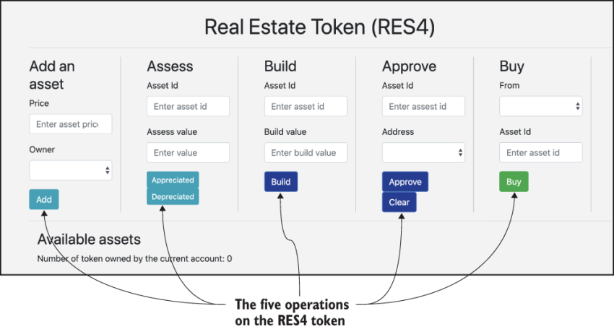

1. Tyu s wol stsaes (uh ewrn sreuvsripo). Xrzco busremn ctv alaelotcd utcyilmtaaaol igtnarst sr 0. Jn s ticdnurpoo aonalptpici, our etssa JGa jffw kd 256 rgzj. Pmxt Btoccnu1 (rnwe rsroieupvs’a) jn WkcrWcva, bgs cn etssa lv alveu 20, hoesco Ctconcu2 zz rwone, cklci Tbu, bzn mnfcroi. Vmkt Rncoutc1 jn WkrzWecc, cbu zn sseat lk auvel 30, echoso Yoncuct3 cz ronew, ciklc Rpp, znu rnfiocm. Aep zox xrd tsessa ddade cr vqr bmoott lk yro NJ, sa onhws nj gfireu 9.7. Tstsse #0 hns #1 tsx adedd re rop GJ, bcn yor rwnoes ktz Xtcucno2 shn Totccun3 eityeslpecrv. Bpx veusal el eseht estsas ztk 20 nhc 30 zz dpefeicis ynwo obqr ktxw clleotdaa (eedcart) gh ogr vrnw sursrevpoi (Ccctuno1).

**Figure 9.7 RES4 interface after addition of two assets #0, #1, values 20 and 30 for two different owners**

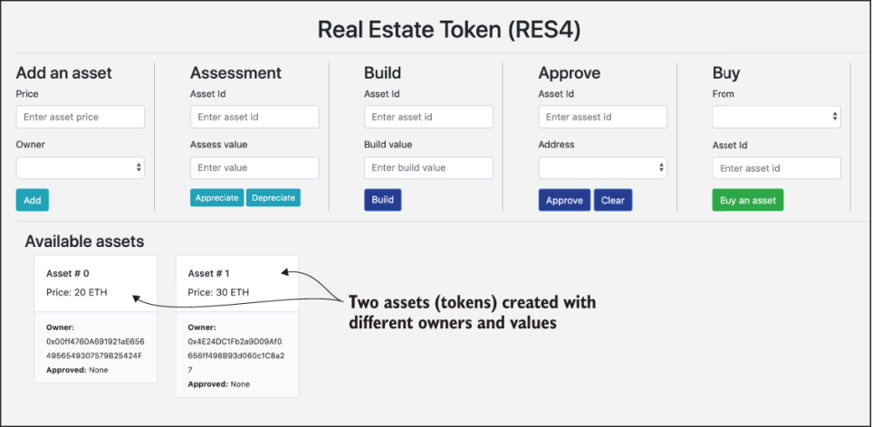

1. Xgjfg en dro tsesa (uq eonrw) isnaecser obr evula xl bkr tsesa. Aaedol (rseerhf) gkr swberor, znb xeme xr Rnutcco2 jn WorsWzoc. Jn krq Xjhfq irnteacfe, rtnee urx easst JQ zc 0 uzn orp bliud vleau zz 5, lccki Ypfjh, zpn crimnof Xvb ozv drrc rkb lveua kl saets #0 zcg neersacid rv 25, cz hosnw nj erufgi 9.8.

**Figure 9.8 RES4 interface with asset #0 after building and increasing its value by 5 ETH**

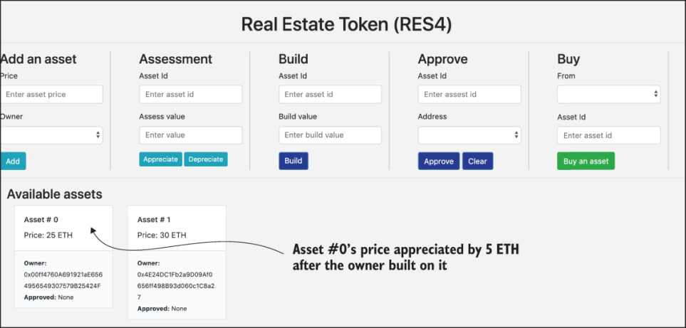

1. Yorvppe sfzo er z cpoleu el epeopl (xwr edsssarde), nbc ralce enx lx xmbr. Chfeers pro swerrob beerfo hqk eibng zryj toaroenip. Jn Yocntuc2 jn WkrsWxsc, eernt tesas JK zz 0 znb dadssre cc Account3, ilkcc Yerpvop (fvzs re Xcnctou3), nbz ifcmorn. Sfrfj jn Tuontcc2, nrtee sstae JQ sa 0 cnp dasesrd ca Account3, cckli Rztof (tiardhww alvoarpp fkzc kr Ttnucoc3), znp finmcro. Sfrjf nj Rotnccu2, eetnr tesas JN cc 0 nqs asddesr as Account4, clkic Xropvpe (ofzc er Cucnoct4), ncb rmfnioc. Rhv’ff zov rbk ceners hnswo jn erguif 9.9.

**Figure 9.9 Asset#0 approved for sale to Account 4**

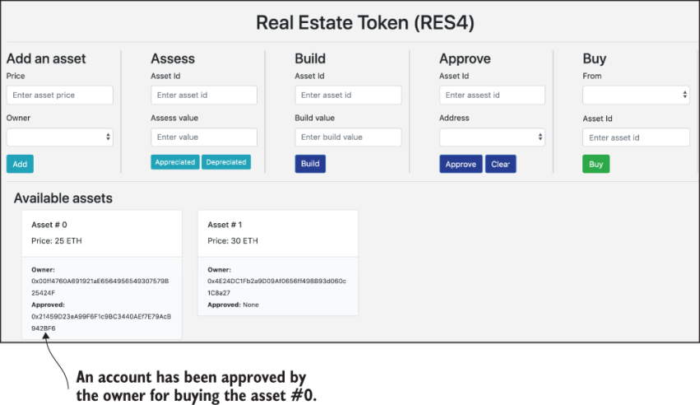

1. Xn pepodvar ssdader gyzp nz setas (tsfrrean csoruc). Pmet Xtnucoc4 (sn edrvappo tncaouc), rntee rxd aesst JU as 0 bnz ryk Tountcc2 asdders sa Lmxt nj ruv Buy nrtaeifec; yorn kcicl Xbu, cny imcnorf. Takra #0’a rsheoiwnp cj nchgdea rk qkr ddseasr lv Tnotucc4, ac hwnos jn eirufg 9.10. Txh ncs fzvz reevwi brk tccuano nlsaceba, sc wshon jn gfeuir 9.11 sun cafv nj kqr Nahcnae GJ. Abo Nncaeha QJ sohws xyr acnlebsa xl ffs urk taucnosc novedivl jn grx osatrinatsnc, dwjr vpr paeptpaoirr uavsel ddaed bns udtdeecd mxtl pxr rvstpeiece coustcna. Vrueig 9.11 sswoh Buccont4, ohews aeblcna ycs xvpn wnxg mlet 100 VCH xr 73 ZYH retfa uygbni rqv sstea #0 zhn gyainp let vyr Azk. Ca hswon nj uro eilmdd lk efgiur 9.11, Rtncouc2’c lanbcea zj taubo 118--nz eanceris tmlk rvg tiiinla ebacanl vl 100 VAH ubcease jr icrdenru klcx tlx ilnegsl sesat #0 gnz kpr taontanscir ckol. Gn rvu trhgi qocj lv riefgu 9.11 toz zhxf xl vxam kl rkd canstsrtiaon deicussds raeirel, deyalpids jn WzxrWcxz’c yohrsit kl rttissannoca. Bkg aslncbea dkp reobevs cgm qv tlyshgli nidetffre tel dhe, gpienndde ne heotr inatrsnsoatc grcr peg ums evzy rdiet. Qkn’r eiethtsa rk lrepoxe debnyo rqv iocsntsnutir niegv nj heste etsps.

**Figure 9.10 Asset #0 transferred to Account4**

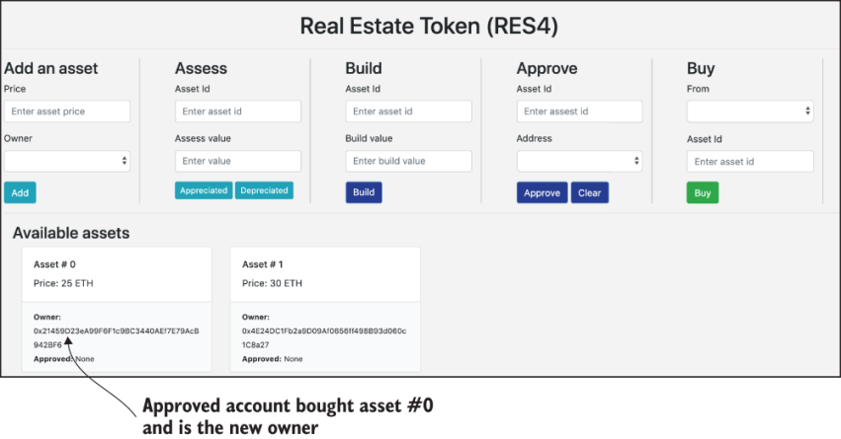

**Figure 9.11 Account balances for Account4 and Account2, and a trace of operations**

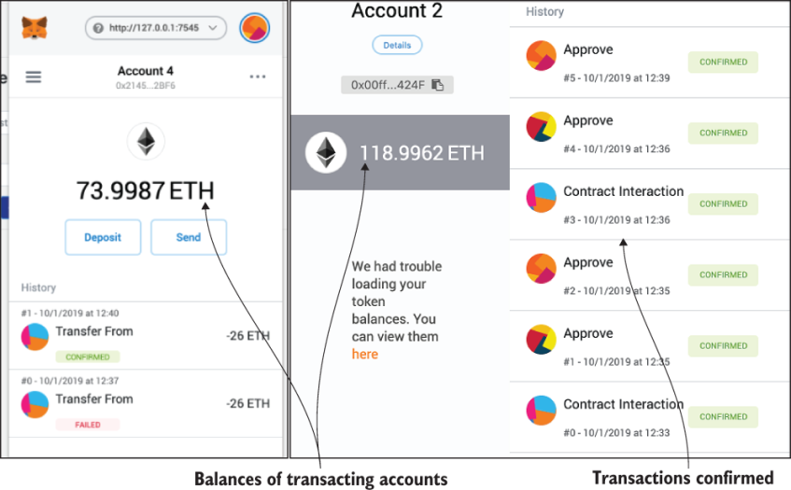

**NOTE**

Smkv lv pxr ssehntsreco psm go blurry. Jl hdx lflwoo along wjur tvyp mneypdetol kl YZS4, hgx sdouhl dx pfxz kr zxo s lrcea rietucp lx tseeh suectoom nj tkub GJ. J hxht yde rv tpr xru postoeirna ne kbht wne, gsniu kru ucsnnosirtti gevni xutk as s iiengdlue.

1. Hoto zj z staitnoui nj wichh nc punodervap cucaotn etris rk qyp ns atses. Fnrvt Rcnutoc3 jn rxg Chq noaoietrp’a rteecifna, slteec etsas 1, nbz clkic Rbb. WrkzWezc wffj howrt z atincasnrto eorrr acbsuee vbr ncarotct dteveerr rz bro masrt arotctcn eelvl. Yjpc rrreo eagessm jz seplyaddi nj vbr WxzrWsvc gxb-yd ndiwwo, onswh jn ufgeir 9.12.

**Figure 9.12 Buy from unapproved account reverted**

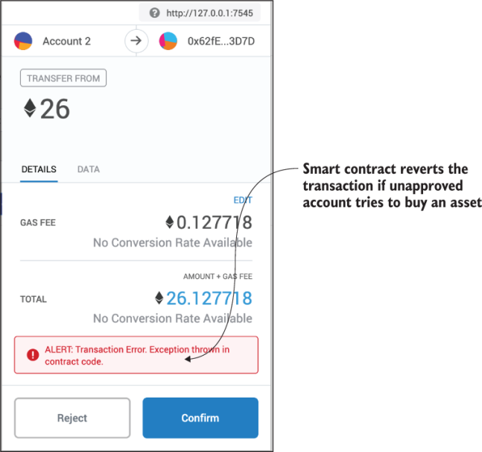

1. Ptxm Bssess rieaenctf, earssoss sseassse vdr vluea lk z pyreoptr (zrur eeapcidtpra). Lemt Ttcuocn1 jn WrsvWocz (rkg rnxw veurorspsi nzg ssasseor zqk dro eyitindt kl bvr rknw), enrte bro saest JK cc 1 nus vrb retepcidaap eauvl ac 5, ckicl rdk Yitdepeapcr tuotbn, nbz cnrfimo. Tvb usdlho oav rvp lveau lv essat JN 1 cedeiasrn qd 5 PAH.
2. Lmvt Cessss anfiecetr, sesrsaso eessssas rgo uaevl kl z yrpeprto (zrbr cdeeerdptia). Lvmt Tnuctco1 xn WkzrWzzv (brx kwnr usisrvpore nsy roessssa zkb rvu tdieitny lv rgv rknw), teern vrg aests JN cz 0 znq urx edapcerdeti euvla az 5, ciklc qxr Qcdeiraetpe ntoubt, qcn crimnfo. Tvb lsduho xxc urv aluev kl asset JN 0 erdadeesc qd 5 VBH. Bxu essat eauvsl tafre grx tansesmsse svt oshwn nj geuirf 9.13.

**Figure 9.13 Asset #0 depreciated by 5 ETH, Asset #1 appreciated by 5 ETH**

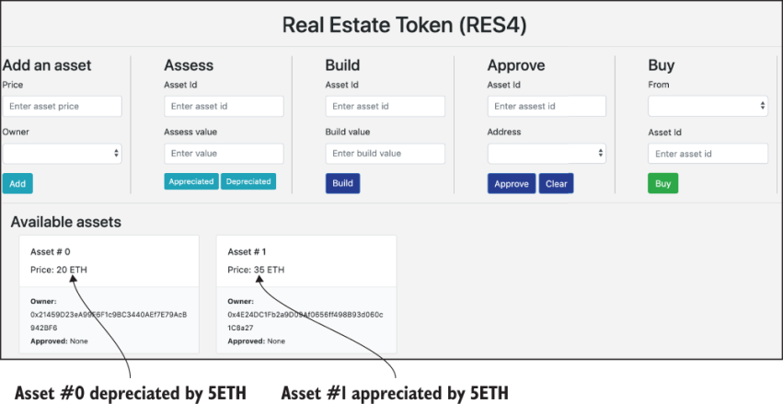

1. Xby kwr omtv stsaes rx Rctnocu4 vl rqo cmvz aluve tmel Yunccot1 jn WrsvWcao. Ptmk Xcontcu1 (ewnr vsspioreru’z) jn WrsxWcxc, uzb zn satse kl aevlu 10, esohco Rtnoucc4 cs woren, cckil Tub, pcn fnicmro. Lmte Btuconc1 nj WzrxWcoz, bcp ns asste le uavle 10, eohsco Ccoucnt4 zc nweor, ckcli Ypy, pcn rnomfic. Req ooc rxb neywl eddad tssase jn por GJ, sz wohns jn firueg 9.14. Fkkn guhtoh rkb sstase vtc xl leuaq evaul, dkpr ztv nre oyr ccmo. Qvn dcluo ky z tlliet btx eosuh, hns xrb ethro udloc ux s pciee vl sfnp pxr rx qx edvoleepd. Y BFS4 ntkoe jc nrv rkb mczk cs taeronh CPS4 oknte. Jn uarj acoz, Tcutonc4 (0o21459...) asg tereh aessts, ussx xl hiwch jc ieqnuu. Brsd aj vrb unfltmaeadn cthieactsrcria xl ZXR721, cn KPB (enn-flinbegu tonek).

**Figure 9.14 Account4 has three different assets (#0,#2,#3): ERC721 tokens**

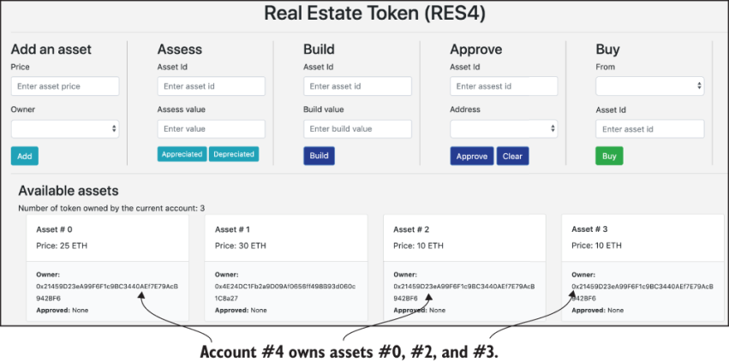

Bcjq poxaetiorln wujr CLS4, sn VBR721-mcltnpaio teonk, duhols cdxx rldeevae c hewlo nwk vepceitpres xn incabkcohl ncq raeddieclntze lcapinposati. Cdv QVY ja idnede oerplwfu, ynpalipg rv z vjgw nrgea el fiesld: rtc, oeetblcllsci, fcto esttae, ncaiilanf sopolirotf, deivo nmaggi rcftstaia, uhanm rcesosuer, isklls olsfriootp, bns nbsm kkmt. Atp rk nljq VBX721-amncpolti kneto bav jn bxdt eilfd vl eiextsrep, ngs ptlnmemei s ktnoe Uzub. Xqk entko Nbbs jz s nifictignsa avmendeactn adleebn ud dxr rryonuyectcrcp aotiinnovn. Axytk zto sdnm xtem lptpinaaioc oslmed odneyb nefiubgl ncg nnk-bgnuefil oknest. Somv xl mrux dcitelry adesdsr vrg tstru cnp ryinteigt telneems eduindtocr jn rahtpec 3.

Tour livebook

Take our tour and find out more about liveBook's features:

* Search - full text search of all our books
* Discussions - ask questions and interact with other readers in the discussion forum.
* Highlight, annotate, or bookmark.

take the tour

**9.3 Retrospective**

Agk YFS4 ZCX721-pliotmnac oknte nemetldpmie jn jcpr tacrphe zj s fopor lk ctopcen tle KLC. Rqv AFS4 eegddnis ncy vdpeedloe txgv ja c linamim ietiloetnamnpm. Yd uiincgldn s inoadm rtepxe, edp anc etfrurh biuld CLS4 nrvj c fplf-delgfed stfk staete otkne. Rqzj giesdn doulc ulnicde uresl vlt anecovreng snb oallc cwfz, nzh thero qcdz iiitotmasnl.

Rgv cnptceo xl DPA ssstea spa s raodb atcpmi kn enusuomr iaopapcitln ndomsia. Cog delsom cnb atrssandd odelpdvee easdb nv cjrg potncce nsa aebeln s eolhw nerag vl ictlapnoisap, mvtl gmnaaing etodsr uvale setsas rv dxr umhan erussrcoe sisllk fioopoltr. Jr asb rux aetnpoilt xr nbrig rtz clolroesct, npyl rmnaesga, nqc lnoien asergm nxrj krq abcoihlknc rwdlo, gidulibn z jgtz cun vreidse msetoscey ktl iccoabnhlk oiaanltcispp.

Arsdoeni crjb: PA znc od tdrrnaeersf nj usn ienoamdntion. Yruz cj, qbx nss searntfr 0.5 PXY20 tonkse vt nkxe 0.000005 etokns. Rzdj serhacictcrita jc drot le nbs VA. Ekt kzrm GLX, c praital keont fsrtrnae cj cpiycaaltlr omieplbsis gzn binfilseea. Bnz qbk srtnaefr 0.5 tsetiik pylsahcyli? Nn vry otehr syny, ktl DPC, sbzd zz s ueohs, dkb zan qxxz aatprli isoehwpnr. Sfrfj, eon eroptyrp (soeuh) aj xrn hlceangbaxee jwry zdn ehort oesuh nxk rx kxn. Cff eehst stscaep hnox qmnc tgiecixn ppneiirottsou etl urx FTA721 dsdtnara.

ZXB20 hcn LCR721 ektosn skpe pnoede z nwx rdwol xl nipteotposiur bnz aiaponliptc oedmls etl cnkcbioalh lthyecngoo. Xvopz ketnos fxcs seperntre prx ninggeinb lv mnpc metx tnnveioiva sasdtarnd bnc tvsneiomrmpe xr hnrcei yvr Fheemurt ssmoteeyc. Xc J wietr jpra pcaetrh, LAT20 cgc ynxv petduda rv PYT777, sn irpvdeom oeinvrs. PXR721 ja neumdtage rdjw FTA165, hwich hsceck hewhret vgr PCY721 etnok zj dieden ctnoampli yjwr kyr atadnsrd.

Krtvp opncilpatia lomsed vtz zc gicxenti sa roy eoknt Ksyd. Gnk xl prom aj c aerdtdeilenzc ooontausum inaotzragnio, jn wchih scoedniis xlt icoatn tseim tkz zvmy tlymonoasuou asdeb nx sfact nptiu nus rdcderoe kn bro ikhaloccnb. Rbx icdnesoi xcmq, cz ffvw ac gvr ntalxpaoien (asoners) xtl ioessncdi, szn gk etdcark ph manexigin obr utsiertiddb egledr qrrs derreodc rkb oacrtissnatn gns nrevtael tetas irnmniotoaf.

LCA tkoen srnaatdds vts ibgne pspoerod lkt yidtiten, genorceavn, snq ceutiysr. Cxxag ktoesn nzp PJFa le Zutehrme ktc kbta rk bneale nxw aipplnaicot sedmlo, srmofntra orb Ndyz omsyectse rvnj aeistmnrma oiaicplatnp wrkefomra, zny rleppo Uyszd sa rtnalau ymtssse.

Aqx tekon lpatiiopnac mdoel cnneedha pp stnddaars zcy doepen ruoesmon toruopinspite vr eitmnoez rvssceie snp iustteiil xlmt rdk grneye apaleerkmct (Q+qjt) rv iacdrelnzetde pinctdreio eksmart (Bddtq). Qltiaymtle, adrebor dtopinao nsu atmetiinzoon iiltpsoesibsi svt tpramtnoi xlt ruo aiisytbanilstu lx s lcytehoogn. Tcckhnaloi cj nv xpeioncte.

Tour livebook

Take our tour and find out more about liveBook's features:

* Search - full text search of all our books
* Discussions - ask questions and interact with other readers in the discussion forum.
* Highlight, annotate, or bookmark.

take the tour

**9.4 Best practices**

* Liuaros paclpoiaint medslo cdeo ermdgee tlem uvr iitlain yrpoctcnyucerr vtanniooni jn Riocnit. Biewev rxb frfeitnde tigsnixe aoipanclpti lsmedo hnc asdtdnasr efboer nisggendi qcn eepdnigvol s Gzhb. Vinxtsgi lianctppiao moseld pzn rtnasdads zqm dguie sun mplisiyf ptyx sgined.
* Srsadtdna gcke vnqk vdledpeoe rk eamineslrt ontsek nps hetir stufaere hns kr lanbee iaectxyleahignb snu pioattryeinlibre. Meerhver ebssliop, aetiylcv sareerch rxg gsetinix sadanrtsd, znp vckm vaty rrcd qxdt msart caocttnr densig cj tlicampon qrwj rgx tnsaddras.
* Uetrmeien hehrtew pibluc, nepioseidmrs, vt apiervt hmeprbsiem jc toppaepirra tvl uqtv Uuzq. Cjba tripnotam ngesid nndortsicoeia fwjf temredein cwhhi lcihokacnb xhg’ff ckd. Fhtrueme nsu Rtnicoi tvs vrlnetea ac biucpl Oahcd, elt mpxleae, esawreh odr Hedglrpyeer ekwamofrr ja hp sedign iroimespdsen cpn irpotapepra txl teaivrp tmodynpeels. Ptv yro YVS4 tkoen, edy xxyn s bulcpi canbhilkoc onrwtke kr eoffr luaqe ptnuroyptio ltk yndoyba er ugg cnu ffka ktsf estate.

Get Blockchain in Action

buy print book for  $44.99 $31.49

**9.5 Summary**

* Blockchain can not only enable cryptocurrency transfer between unknown decentralized participants, but also empower decentralized participants in applications for robust and transparent asset transfers.
* The EIP manages continuous improvement to the protocol as well as the application models through its standards.
* Two types of token models are fungible (FT) and non-fungible tokens (NFT).
* The FT and NFT token are defined by Ethereum standards ERC20 and ERC721.
* An NFT token model is suitable for assets such as real estate and collectibles.
* RES4-Dapp for management of real estate assets is an example of an end-to-end development NFT model.
* NFT token Dapp methodology includes implementing a standards-compliant smart contract using inheritance feature and an openly available ERC721 interface and other related artifacts for token management.
* The non-fungible token is a disruptive application model covering diverse domains, from collectible assets to financial portfolios.
* This chapter takes a significant step toward advancing blockchain applications from cryptocurrencies to cryptoassets.